October 7, 2012 Dr. John K. LaShell
1 Corinthians 13:4-5 (2)

I Me!!
A certain kind of self-love—that is loving one’s own happiness—is not wrong. In fact, it is an inevitable part of our creation. However, self-love has been distorted by sin.

1. Sinful self-love is exhibited by pride. It—

A. Is arrogant = puffed up
with an inflated view of our own importance

B. Is jealous (envious, zealous) = unhappy
because others have what we don’t
or because we are protecting our privileges (Mark 9:38)

C. It brags (boasts) = gloats
over what we have that others don’t

D. Acts unbecomingly (rude) = insensitive
to matters of morality, culture and courtesy

2. Sinful self-love is constricted by the self
Love...does not seek its own (v. 5; see 10:24, 33).

A. Natural self-love

i) Narrow self-love seeks happiness

- only in good things for the self

ii) Expanded self-love seeks happiness

- in good things for the self

- in good things for those related to the self
Matthew 5:43-48

B. Spiritual self-love finds happiness (Matthew 22:37-40)

- in God is honored, trusted, and loved

- in doing good to others for God’s sake

- in the new commandment of Christ
Compare Leviticus 19:18 with John 13:34; 15:12-13
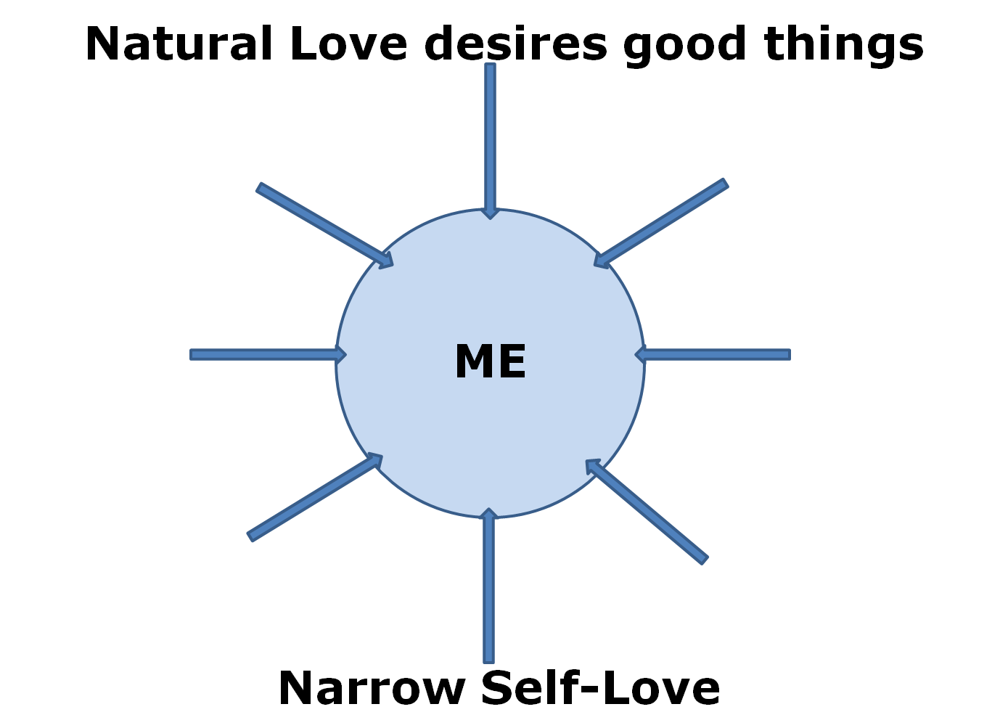

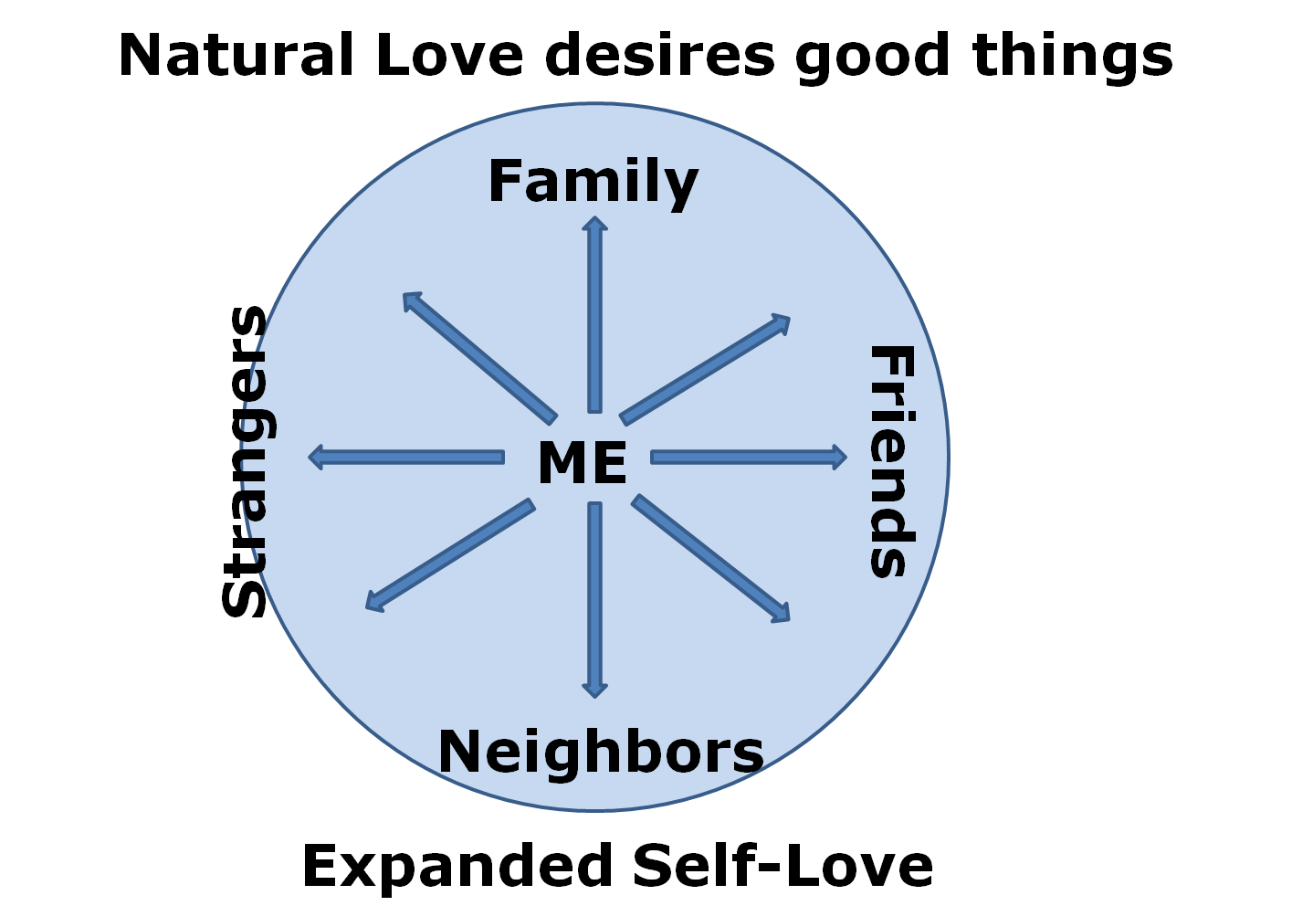
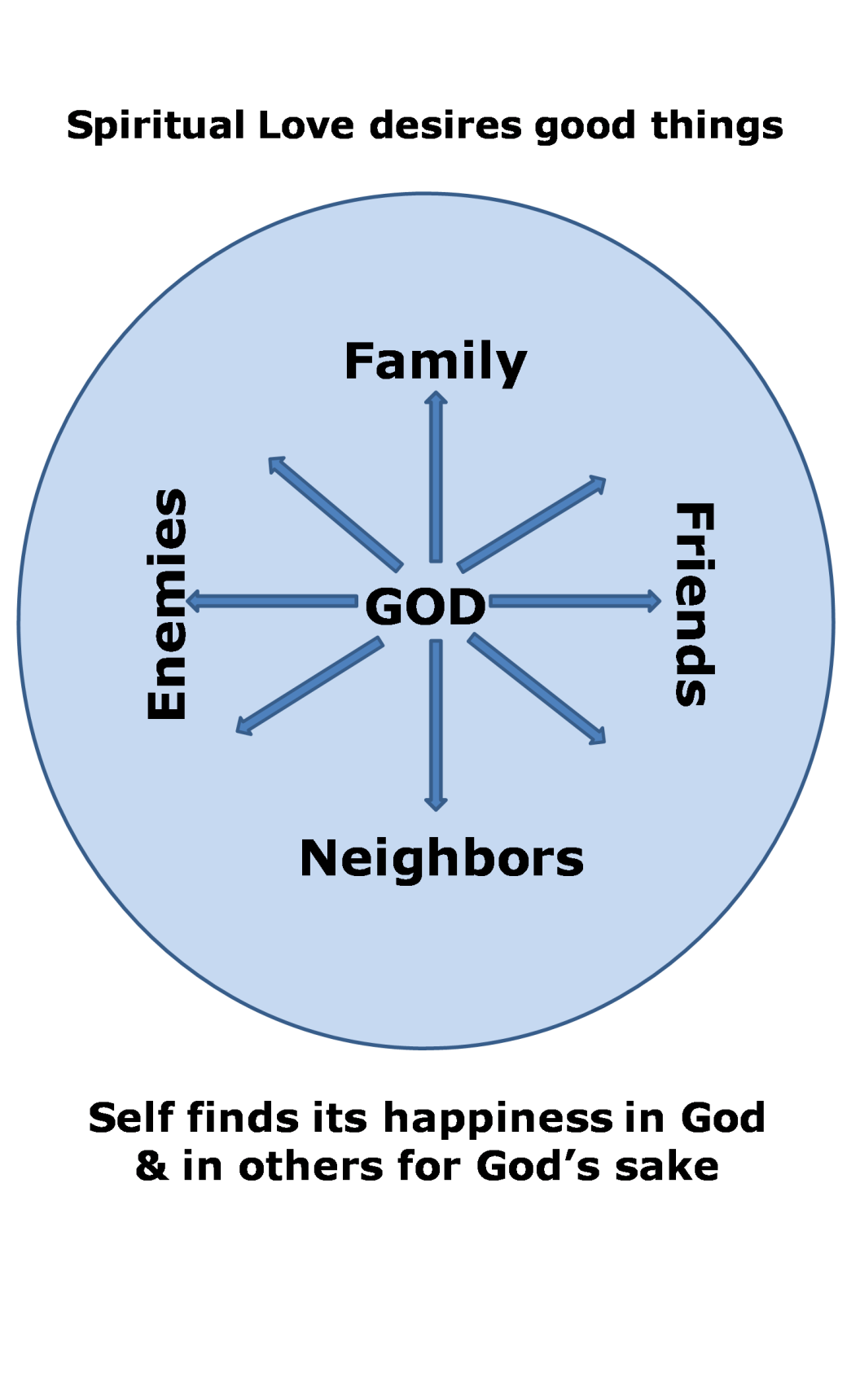

Concluding Application

Self-examination leads us to see that much of our love is natural and self-centered. How ought we to respond?

A. With humility in view of our natural self-centeredness

B. With thankfulness for Christ’s amazing love

C. With dependence on the Spirit for His love

For Private Meditation or Family Discussion

1. What was the most important or helpful thing you heard in the sermon?

2. What questions did the sermon raise in your mind?

3. What was the most challenging or convicting part of the message?

4. If spiritual love for people loves others because of their relation to God (either real or potential), how can you foster a more spiritual love for others? What might a spiritual love for others move you to do that you would not do based merely on a natural love for them.

5. Since natural love for others is not evil, we do not need to worry about replacing it with spiritual love for them. However, natural love is not particularly virtuous either, so we ought not praise ourselves for the kind of love that a non-Christian might demonstrate.

It is probably not beneficial to try to figure out how much of your love comes from the Holy Spirit. At the same time it is profitable always to be depending on the Spirit and asking the Spirit to fill you with His love.

