Superstitious Religion

They that do not believe the Bible will believe anything. They may believe that a man is able to put himself into a quart bottle (John Wesley, 1774). Unfortunately (as we see in Acts 19), those who profess to believe the Bible may not be much better. 1 Samuel 4-6 illustrates several marks of superstitious religion.

1. Powerful Talismans (4:1-9)
(Sacred or magical objects)

2. Trial by Combat (4:10-11; 5:1—10)

3. Fear without Repentance (5:11-6:12)

4. Irreverent Curiosity (6:13-21)
1 Timothy 1:3-7

5. No Glory (4:12-22)
This is the meaning of the name Ichabod.

For additional study or family discussion

1. What did the Lord say to you today through His word? Did you learn some new truth about God or yourself? Did the Lord challenge you, convict you, or encourage you?

2. God reveals His glory in all of His works—in creation, in judgment, in redemption, and in the consummation of all things. In the Old Testament the tabernacle built by Moses and later the temple built by Solomon became the seat of God’s glory on earth. Where and how did God manifest His glory in the following passages?
Exodus 40:17, 33-38
2 Chronicles 5:1-14, 7:1-3
Ezekiel 10:1-22; 11:22-25 (Before the temple was destroyed)
Ezekiel 43:1-5 (When Christ comes again to a new temple)

3. Where will God reveal His glory forever and ever (Ephesians 3:20-21)?

4. How can you display His glory now (Philippians 1:9-11)?

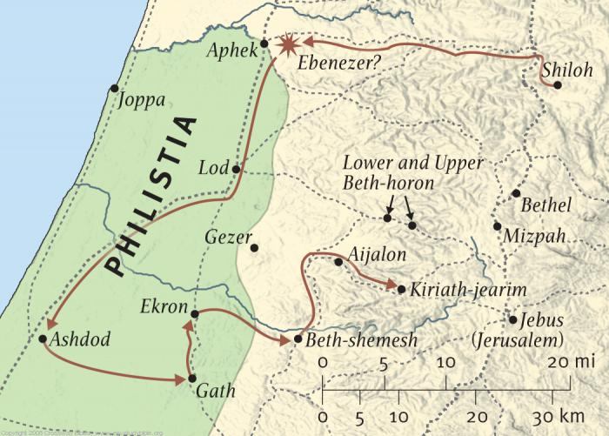
“Journeys of the Ark” from the ESV Study Bible

